Problem to be solved
Increasing the capabilities of research in Egypt’s laboratories through recycling electronic waste

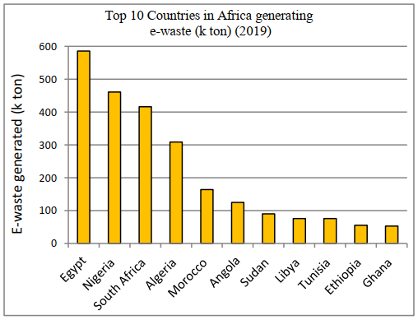
Electronic waste, defined as any electronic appliance that is considered to have reached the end of its usefulness, has been rapidly increasing in the Egyptian landfill sites & markets. According to GEWSP (The Global E-Waste Statistics Partnership) electronic waste in the Egyptian market (EEE) has increased from 754.0 kt in 2015 to 1069.0 kt in 2019. As e waste generated increased from 477.0 kt in 2015 to 586.0 kt in 2019 & e waste generated (kg per capita) increased from 5.16 kg to 5.85 kg. Additionally, said increase in electronic waste is reflected in figure 1 through Egypt’s rank in electronic waste generation among African countries.
Figure 1: Top 10 countries in Africa generating e-waste (k-ton) (2019). Source: The Global E-waste monitor 2020
Source

s

Consequently, the increase in EEE put on the market is almost 3.6 times the increase in population, while the increase in e-waste generated is almost double the increase in population. In average, the e-waste generated is almost 58.7 % of the amount of EEE put on the market. The e-waste generated per capita is 5.84kg/capita at increasing rate of 2.66%. The e-waste generated in Egypt is about 20.1% that of the African continent, while the population in Egypt is about 8.6% of Africa. Previous statements in addition to the lack of any official large-scale projects to recycle electronic waste led to tons of precious materials such as gold, silver, palladium and indium to be wasted. As the waste is instead handled by local garbage traders & collectors.

Positive Consequences

1- Lower Precious Metal Prices
Electronic waste contains precious metals that could be extracted in specialized sites and be reused in other industries or sold directly to the market. According to a research paper published by OR Spectrum, electronic waste is typically compromised by 20.1% Copper, 8.1% Iron, 4.0% Tin, 2.0% Nickel, 2.0% Lead, 2.0% Aluminum, 2.0% Silver, 1.0% Zinc, 0.1% Gold, and trace amounts of palladium.
However, these materials are seldom extracted due to the lack of any official large scale e-waste recycling projects, thus Egypt loses tons of precious materials of significant values yearly.
Utilizing electronic waste recycling sites would greatly reduce the price of these metals by increasing the production and supply of precious metals.
2- Reduce Pollution
586.0 kt of electronic waste is disposed off in Egypt that gradually end up in landfill sites and garbage traders. Parts of these electronics are scrapped for iron and copper by local garbage recyclers that do not have the capacity to recycle the waste to its fullest potential. As only 20% of the e-waste is properly recycled and the remaining 80% is driven into uncontrolled landfills.
Furthermore, this influx of electronic waste into landfill sites contributes to the municipal solid waste as MSW production has reached 0.3 to 0.8 kg//capita as stated by the Egyptian Environmental Affairs Agency (EEAA), which increases yearly at rate of 3.4%. In addition to that, more than 60% of electronic waste is non-metal materials which are often disposed of in the environment by the local garbage traders and recyclers in addition to metals that aren’t profitable to recycle in a small scale, which increases plastic & heavy metal poisoning.
Therefore, deploying country-wide electronic waste management sites would contribute to reducing pollution in Egypt through reduction of the MSW increase, uncontrolled garbage traders, and plastics poisoning.
3- Aid Innovation Increase
Egyptian research institution and universities have a lack of research equipment such as computers & laboratory machines. As a result, Egypt lacks in innovation compared to other countries of the region, as according to ECASTI Egypt has a GII level of 108 out of 142 countries where only four Arab countries are ranked lower than Egypt on the GII: Syria, Algeria, Sudan and Yemen.
Utilizing electronic waste to produce said equipment would reduce the costs of elevating the innovation of Egypt. The waste could be scrapped for raw materials or parts that are then assembled into new, functional research equipment.
Negative Consequences
1- Water and Soil Intoxication
Untreated electronic waste allocated to uncontrolled landfill sites and illegal garbage traders and recyclers pose a significant threat to soil and water. As untreated electronic waste typically have 60.4% of non-metal materials which a local garbage trader cannot treat, instead burning in a landfill or throwing them in a body of water.
Furthermore, some components from electronic waste such as PVC plastics release dangerous gases such as hydrochloric acid into the atmosphere when burned which form acidic rain and intoxicating the air.
Other components such as LCD panels contain poisonous metals such as mercury which are released into bodies of water, infecting wildlife and soil.
2- Spread of Uncontrolled Recyclers
Uncontrolled recyclers and garbage traders in Egypt are considered a widespread issue in the face of the sanitation industry, due to their unregulated methods of recycling. For instance, non-metal materials are overseen by recyclers and are either burned or thrown into uncontrolled landfill sites.
Rapid increase of electronic waste fuels such industry by providing sources of copper, iron and aluminum, which typically make 30.2% of the waste. The collected materials are then either sold or processed in low-tech environments, where the rest of the waste components get burned and released into the environment.
3- Revenue Loss
Globally, USD 91 billion is wasted every year through electronic waste, which reflects the cruciality of electronic waste recycling sites. Yearly, 586.0 kt of electronic waste is generated in Egypt, only 20% of which is recycled while 80% are lost in landfills & illegal recyclers.
Typical electronical waste components are composed of 0.1% gold, which makes up for 88% of income from electronic waste. Additionally, the waste typically contains 0.2% Silver and 20.1% copper, which are all profitable metals, not considering iron and non-metal components also able to be recycled for profit.
With that in mind, only 20% of this waste is properly recycled. Which means millions of possible revenues are lost yearly. Including job opportunities, innovation advancement, environmental improvement, and industrial development.

